Ali Alkhulaqi, Sudhir Sukai

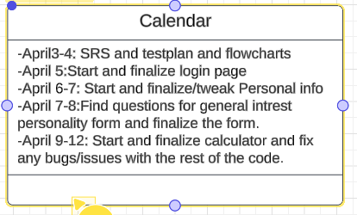

General interest srs: This program is intended to ask the user a set of questions and they choose whether yes or no. Based on their choices it will display their personality and some little information about the personality.

Login page:This program will Take in a username and password cross check the data and if matched takes the user to another web page carrying username over

Calculator: This program is intended to function as a regular calculator but additionally calculates financial information based on the user's input. Functions such as yearly income/monthly income, interest, and etc… Afterwards the information will be displayed into a label for the user to see all of his information he has put until this point.

Personal info: This program will take in info such as email age etc, and once submitted will check the boxes for content and subsequently display this info on another page.